**Python Introduction**

**Python** is a general purpose, dynamic, high level and interpreted programming language. It supports Object Oriented programming approach to develop applications. It is simple and easy to learn and provides lots of high-level data structures.

Python is easy to learn yet powerful and versatile scripting language which makes it attractive for Application Development.

Python's syntax and dynamic typing with its interpreted nature, makes it an ideal language for scripting and rapid application development.

Python supports multiple programming pattern, including object oriented, imperative and functional or procedural programming styles.

Python is not intended to work on special area such as web programming. That is why it is known as multipurpose because it can be used with web, enterprise, 3D CAD etc.

We don't need to use data types to declare variable because it is dynamically typed so we can write a=10 to assign an integer value in an integer variable.

Python makes the development and debugging fast because there is no compilation step included in python development and edit-test-debug cycle is very fast.

# Python History

* Python laid its foundation in the late 1980s.
* The implementation of Python was started in the December 1989 by **Guido Van Rossum** at CWI in Netherland.
* In February 1991, van Rossum published the code (labeled version 0.9.0) to alt.sources.
* In 1994, Python 1.0 was released with new features like: lambda, map, filter, and reduce.
* Python 2.0 added new features like: list comprehensions, garbage collection system.
* On December 3, 2008, Python 3.0 (also called "Py3K") was released. It was designed to rectify fundamental flaw of the language.
* ABC programming language is said to be the predecessor of Python language which was capable of Exception Handling and interfacing with Amoeba Operating System.
* Python is influenced by following programming languages:
  + ABC language.
  + Modula-3

# Python Features

Python provides lots of features that are listed below.

#### 1) Easy to Learn and Use

Python is easy to learn and use. It is developer-friendly and high level programming language.

#### 2) Expressive Language

Python language is more expressive means that it is more understandable and readable.

#### 3) Interpreted Language

Python is an interpreted language i.e. interpreter executes the code line by line at a time. This makes debugging easy and thus suitable for beginners.

#### 4) Cross-platform Language

Python can run equally on different platforms such as Windows, Linux, Unix and Macintosh etc. So, we can say that Python is a portable language.

#### 5) Free and Open Source

Python language is freely available at [offical web address](https://www.python.org/" \t "blank).The source-code is also available. Therefore it is open source.

#### 6) Object-Oriented Language

Python supports object oriented language and concepts of classes and objects come into existence.

#### 7) Extensible

It implies that other languages such as C/C++ can be used to compile the code and thus it can be used further in our python code.

#### 8) Large Standard Library

Python has a large and broad library and prvides rich set of module and functions for rapid application development.

#### 9) GUI Programming Support

Graphical user interfaces can be developed using Python.

#### 10) Integrated

It can be easily integrated with languages like C, C++, JAVA etc.

# Python Applications

Python is known for its general purpose nature that makes it applicable in almost each domain of software development. Python as a whole can be used in any sphere of development.

Here, we are specifing applications areas where python can be applied.

#### 1) Web Applications

We can use Python to develop web applications. It provides libraries to handle internet protocols such as HTML and XML, JSON, Email processing, request, beautifulSoup, Feedparser etc. It also provides Frameworks such as Django, Pyramid, Flask etc to design and delelop web based applications. Some important developments are: PythonWikiEngines, Pocoo, PythonBlogSoftware etc.

#### 2) Desktop GUI Applications

Python provides Tk GUI library to develop user interface in python based application. Some other useful toolkits wxWidgets, Kivy, pyqt that are useable on several platforms. The Kivy is popular for writing multitouch applications.

#### 3) Software Development

Python is helpful for software development process. It works as a support language and can be used for build control and management, testing etc.

#### 4) Scientific and Numeric

Python is popular and widely used in scientific and numeric computing. Some useful library and package are SciPy, Pandas, IPython etc. SciPy is group of packages of engineering, science and mathematics.

#### 5) Business Applications

Python is used to build Bussiness applications like ERP and e-commerce systems. Tryton is a high level application platform.

#### 6) Console Based Application

We can use Python to develop console based applications. For example: **IPython**.

#### 7) Audio or Video based Applications

Python is awesome to perform multiple tasks and can be used to develop multimedia applications. Some of real applications are: TimPlayer, cplay etc.

#### 8) 3D CAD Applications

To create CAD application Fandango is a real application which provides full features of CAD.

#### 9) Enterprise Applications

Python can be used to create applications which can be used within an Enterprise or an Organization. Some real time applications are: OpenErp, Tryton, Picalo etc.

#### 10) Applications for Images

Using Python several application can be developed for image. Applications developed are: VPython, Gogh, imgSeek etc.

There are several such applications which can be developed using Python

# How to Install Python (Environment Set-up)

In this section of the tutorial, we will discuss the installation of python on various operating systems.

### Why Python

* Python works on different platforms (Windows, Mac, Linux, Raspberry Pi, etc).
* Python has a simple syntax similar to the English language.
* Python has syntax that allows developers to write programs with fewer lines than some other programming languages.
* Python runs on an interpreter system, meaning that code can be executed as soon as it is written. This means that prototyping can be very quick.
* Python can be treated in a procedural way, an object-orientated way or a functional way.

### Good to know

* The most recent major version of Python is Python 3, which we shall be using in this tutorial. However, Python 2, although not being updated with anything other than security updates, is still quite popular.
* In this tutorial Python will be written in a text editor. It is possible to write Python in an Integrated Development Environment, such as Thonny, Pycharm, Netbeans or Eclipse which are particularly useful when managing larger collections of Python files.

### Python Syntax compared to other programming languages

* Python was designed for readability, and has some similarities to the English language with influence from mathematics.
* Python uses new lines to complete a command, as opposed to other programming languages which often use semicolons or parentheses.
* Python relies on indentation, using whitespace, to define scope; such as the scope of loops, functions and classes. Other programming languages often use curly-brackets for this purpose.

## Installation on Windows

Visit the link <https://www.python.org/downloads/> to download the latest release of Python. In this process, we will install Python 3.6.7 on our Windows operating system.

Double-click the executable file which is downloaded; the following window will open. Select Customize installation and proceed.

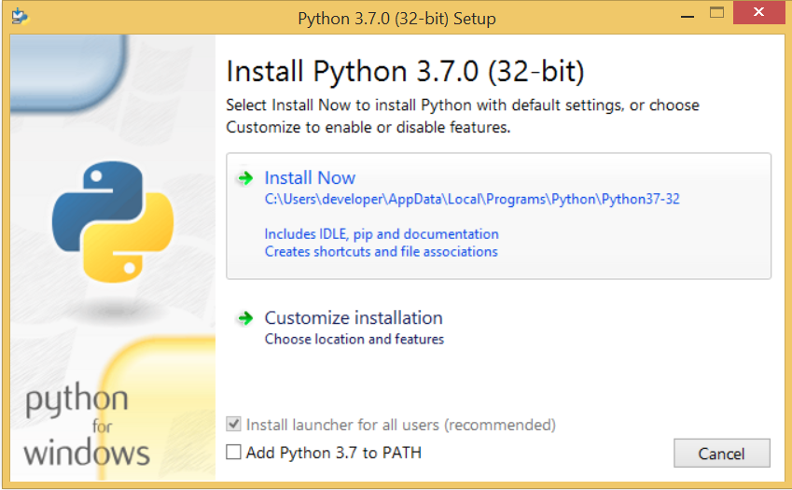 

The following window shows all the optional features. All the features need to be installed and are checked by default; we need to click next to continue.

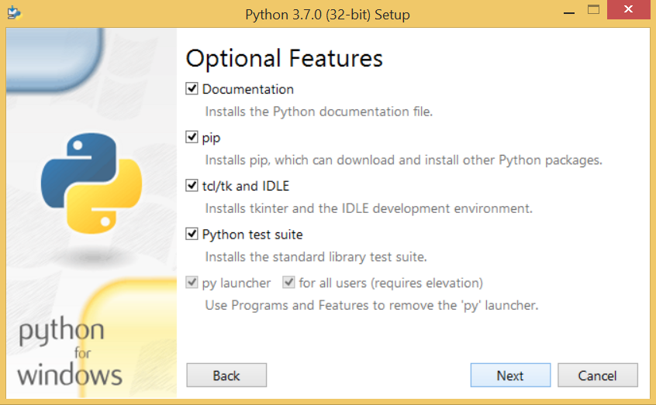 

The following window shows a list of advanced options. Check all the options which you want to install and click next. Here, we must notice that the first check-box (install for all users) must be checked.

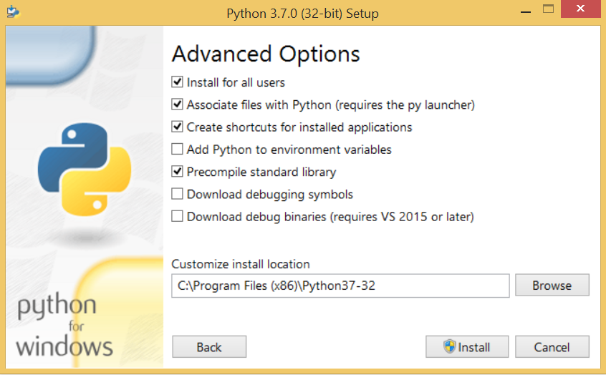

Now, we are ready to install python-3.6.6. Lets install it.

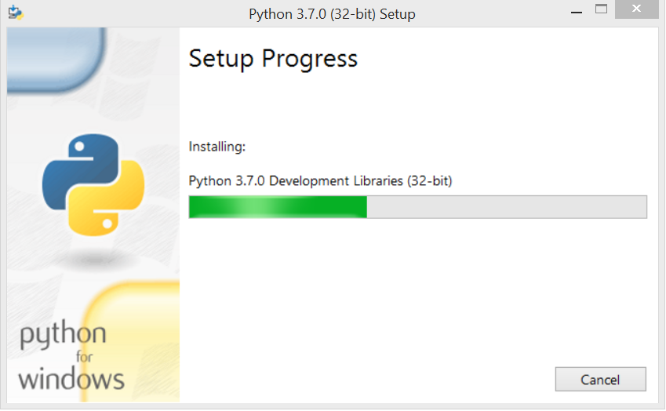

Now, try to run python on the command prompt. Type the command python in case of python2 or python3 in case of python3. It will show an error as given in the below image. It is because we haven't set the path.

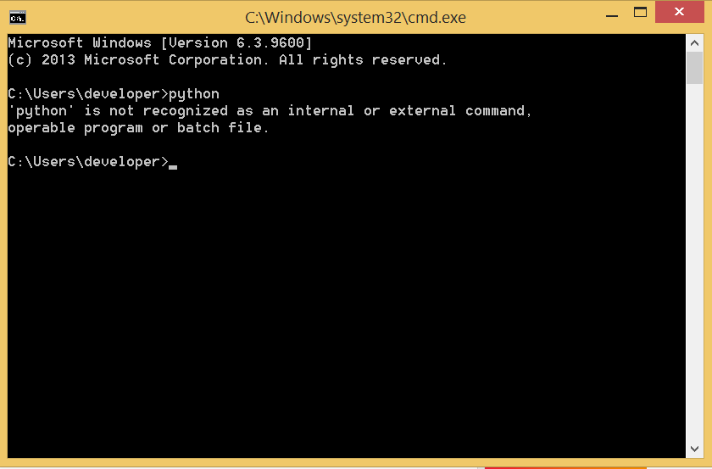

To set the path of python, we need to the right click on "my computer" and go to Properties → Advanced → Environment Variables.

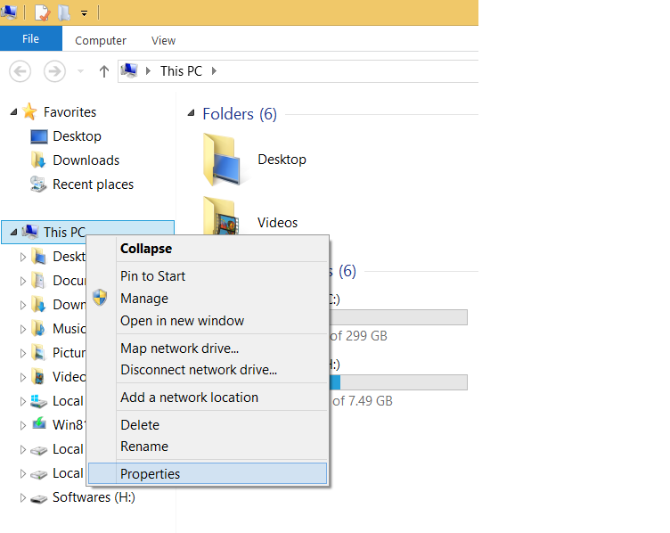

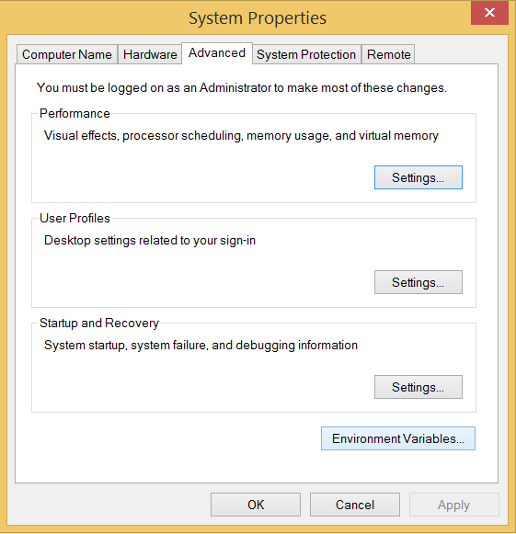

Add the new path variable in the user variable section.

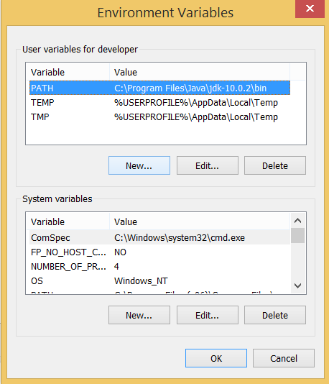

Type PATH as the variable name and set the path to the installation directory of the python shown in the below image.

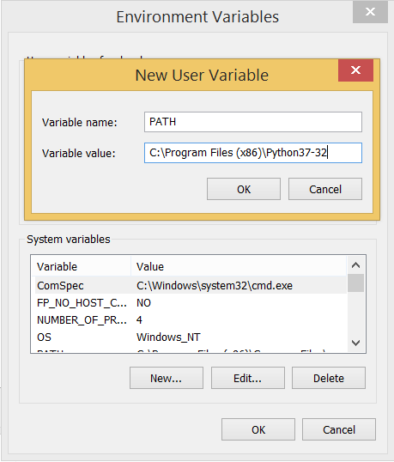

Now, the path is set, we are ready to run python on our local system. Restart CMD, and type python again. It will open the python interpreter shell where we can execute the python statements.

**Virtual Environments and Packages**

**Introduction**

Python applications will often use packages and modules that don’t come as part of the standard library. Applications will sometimes need a specific version of a library, because the application may require that a particular bug has been fixed or the application may be written using an obsolete version of the library’s interface.

This means it may not be possible for one Python installation to meet the requirements of every application. If application A needs version 1.0 of a particular module but application B needs version 2.0, then the requirements are in conflict and installing either version 1.0 or 2.0 will leave one application unable to run.

The solution for this problem is to create a virtual environment, a self-contained directory tree that contains a Python installation for a particular version of Python, plus a number of additional packages.

Different applications can then use different virtual environments. To resolve the earlier example of conflicting requirements, application A can have its own virtual environment with version 1.0 installed while application B has another virtual environment with version 2.0. If application B requires a library be upgraded to version 3.0, this will not affect application A’s environment.

**Creating Virtual Environments**

The module used to create and manage virtual environments is called venv. venv will usually install the most recent version of Python that you have available. If you have multiple versions of Python on your system, you can select a specific Python version by running python3 or whichever version you want.

To create a virtual environment, decide upon a directory where you want to place it, and run the venv module as a script with the directory path:

python3 -m venv tutorial-env

This will create the tutorial-env directory if it doesn’t exist, and also create directories inside it containing a copy of the Python interpreter, the standard library, and various supporting files.

A common directory location for a virtual environment is .venv. This name keeps the directory typically hidden in your shell and thus out of the way while giving it a name that explains why the directory exists. It also prevents clashing with .env environment variable definition files that some tooling supports.

Once you’ve created a virtual environment, you may activate it.

On Windows, run:

tutorial-env\Scripts\activate.bat

On Unix or MacOS, run:

source tutorial-env/bin/activate

(This script is written for the bash shell. If you use the csh or fish shells, there are alternate activate.csh and activate.fish scripts you should use instead.)

Activating the virtual environment will change your shell’s prompt to show what virtual environment you’re using, and modify the environment so that running python will get you that particular version and installation of Python. For example:

$ source ~/envs/tutorial-env/bin/activate

(tutorial-env) $ python

Python 3.5.1 (default, May 6 2016, 10:59:36)

...

>>> import sys

>>>sys.path

['', '/usr/local/lib/python35.zip', ...,

'~/envs/tutorial-env/lib/python3.5/site-packages']

>>>

**Managing Packages with pip**

You can install, upgrade, and remove packages using a program called pip. By default pip will install packages from the Python Package Index, <https://pypi.org>. You can browse the Python Package Index by going to it in your web browser, or you can use pip’s limited search feature:

(tutorial-env) $ pip search astronomy

skyfield - Elegant astronomy for Python

gary - Galactic astronomy and gravitational dynamics.

novas - The United States Naval Observatory NOVAS astronomy library

astroobs - Provides astronomy ephemeris to plan telescope observations

PyAstronomy - A collection of astronomy related tools for Python.

...

pip has a number of subcommands: “search”, “install”, “uninstall”, “freeze”, etc. (Consult the Installing Python Modules guide for complete documentation for pip.)

You can install the latest version of a package by specifying a package’s name:

(tutorial-env) $ pip install novas

Collecting novas

Downloading novas-3.1.1.3.tar.gz (136kB)

Installing collected packages: novas

Running setup.py install for novas

Successfully installed novas-3.1.1.3

You can also install a specific version of a package by giving the package name followed by == and the version number:

(tutorial-env) $ pip install requests==2.6.0

Collecting requests==2.6.0

Using cached requests-2.6.0-py2.py3-none-any.whl

Installing collected packages: requests

Successfully installed requests-2.6.0

If you re-run this command, pip will notice that the requested version is already installed and do nothing. You can supply a different version number to get that version, or you can run pip install --upgrade to upgrade the package to the latest version:

(tutorial-env) $ pip install --upgrade requests

Collecting requests

Installing collected packages: requests

Found existing installation: requests 2.6.0

Uninstalling requests-2.6.0:

Successfully uninstalled requests-2.6.0

Successfully installed requests-2.7.0

pip uninstall followed by one or more package names will remove the packages from the virtual environment.

pip show will display information about a particular package:

(tutorial-env) $ pip show requests

---

Metadata-Version: 2.0

Name: requests

Version: 2.7.0

Summary: Python HTTP for Humans.

Home-page: http://python-requests.org

Author: Kenneth Reitz

Author-email: me@kennethreitz.com

License: Apache 2.0

Location: /Users/akuchling/envs/tutorial-env/lib/python3.4/site-packages

Requires:

pip list will display all of the packages installed in the virtual environment:

(tutorial-env) $ pip list

novas (3.1.1.3)

numpy (1.9.2)

pip (7.0.3)

requests (2.7.0)

setuptools (16.0)

pip freeze will produce a similar list of the installed packages, but the output uses the format that pip install expects. A common convention is to put this list in a requirements.txt file:

(tutorial-env) $ pip freeze > requirements.txt

(tutorial-env) $ cat requirements.txt

novas==3.1.1.3

numpy==1.9.2

requests==2.7.0

The requirements.txt can then be committed to version control and shipped as part of an application. Users can then install all the necessary packages with install -r:

(tutorial-env) $ pip install -r requirements.txt

Collecting novas==3.1.1.3 (from -r requirements.txt (line 1))

...

Collecting numpy==1.9.2 (from -r requirements.txt (line 2))

...

Collecting requests==2.7.0 (from -r requirements.txt (line 3))

...

Installing collected packages: novas, numpy, requests

Running setup.py install for novas

Successfully installed novas-3.1.1.3 numpy-1.9.2 requests-2.7.0

pip has many more options. Consult the Installing Python Modules guide for complete documentation for pip. When you’ve written a package and want to make it available on the Python Package Index, consult the Distributing Python Modules guide.